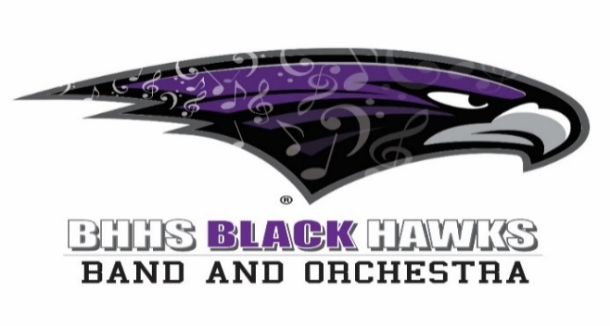

BBOB General Meeting – January 8, 2024

1. Welcome | Mark James/Mike Morgan
- Called to order at 5:00 PM

2. Director’s Report – Orchestra | Sean Brennan
- Put together materials for summer orchestra retreat
- Seeking input for participation fee
- Looking to provide Swag, lunch, and snacks
- Considering Long Weekend at the school
- Can BBOB help facilitate up front costs, provide volunteers, and help coordinate lunch / snacks

3. Director’s Report – Band | Alan Posner
- Aretha’s Jazz Café next Tuesday
- District 4 honors band this weekend
- Michigan Music Conference
- Students going + Klesmer Ensemble
- CMU Jazz Thurs Feb 8
- Solo + Ensemble – Feb 9&10
- Mark willing to work with us on the trailer key / lock situation

4. Status of Direct Donation Drive 2023  - Have collected $9100  - Some still need to donate  - We should continue every year  - Alan would like to see a breakdown of who donated (Parents, Students, Alumni, Community, etc.) | Mark, Sarah & Directors
5. Future Festivals and Concerts | Mark
- Pre-Festival (Feb. 22, 2024)
- MAPA Percussion Competition (Feb. 24, 2024)  MI Alliance for Performing Arts/BHHS Music Booster  - Wanted to move from West Bloomfield  - Feb 24 – 10 Ensembles  - Adjudicated performance (Like a marching band festival)  - Up front work + Work on Day of  - Will get 60 – 80%. $10 per person admissions  - Should be about 1K people  - On the 23rd we will need to pick up their trailer  - Will need to pick up judges at airport  - Need to manage logistics drop off  - If we do a good job, should be able to do annually and make $6K - $8K annually.  - Questions about concessions can go to Karl and he will ask those who worked last year  - Do we want to have any of our teams adjudicated? Alan will look into it.  - Can we get an announcer? Ask the BIFF. Karl to send information to Alan.  - Any questions to Karl - karlknas@yahoo.com | Karl Knas
- B3 Concert (Feb. 28, 2024)
- MSBOA Band and Orchestra Festival (Mar. 7 & 8, 2024) – May be one day. Will be a crazy day. Non-Perishable concessions.
- MSBOA Jazz Festival (Mar. 19, 2024)
- NHMS - 6th- 8th Grade Spring Band Concert at BHHS (June 3, 2024)
- Concerto Concert (June 5, 2024)
- NHMS - 6th-8th Spring Orchestra Concert at BHHS (June 10, 2024)
- District 4 is considering allowing us to charge admission up to $5 / person for the marching band festival and we need to split it with the MSBOA
- Would like a large sign that says CONCESSIONS

6. Next Action Steps & Deadlines | All
7. Meeting Adjourn | Mark
- Adjourned at 5:32

